Amazon SageMaker

Table of Contents

Sentiment Analysis 1

Preparing the Environment 1

Training 2

Evaluate 2

Obtaining and Viewing All Predictions 3

Save and Load the Model 4

Continuous Training 4

Object Detection 4

Uploading your Own Images 9

## Sentiment Analysis

This section is based on the quick start tutorial at:

<https://auto.gluon.ai/stable/tutorials/multimodal/text_prediction/beginner_text.html>

### Preparing the Environment

An error occurs when running the code for the tutorial. The error may occur because ipywidgets 8 conflicts with the other libraries.

To view your version of ipywidgets run the following code:

|  |
| --- |
| import ipywidgets  ipywidgets.__version__ |

To downgrade to a more stable version of ipywidgets, like version 7.0.0, run the following command and remember to restart the kernel when finished.

|  |
| --- |
| pip install ipywidgets==7.0.0 |

Running the code in this next step loads the Stanford Sentiment Treebank ([SST](https://nlp.stanford.edu/sentiment/)) dataset, which consists of movie reviews and their associated sentiment. Given a new movie review, the goal is to predict the sentiment reflected in the text (in this case a **binary classification**, where reviews are labeled as 1 if they convey a positive opinion and labeled as 0 otherwise). Let’s first load and look at the data, noting the labels are stored in a column called **label**.

The parquet format here is used but of course you could load this data from a csv file or other data source.

|  |
| --- |
| %matplotlib inline  import numpy as np  import warnings  import matplotlib.pyplot as plt  warnings.filterwarnings('ignore')  np.random.seed(123)  from autogluon.core.utils.loaders import load_pd  train_data = load_pd.load('https://autogluon-text.s3-accelerate.amazonaws.com/glue/sst/train.parquet')  test_data = load_pd.load('https://autogluon-text.s3-accelerate.amazonaws.com/glue/sst/dev.parquet')  subsample_size = 1000 # subsample data for faster demo, try setting this to larger values  train_data = train_data.sample(n=subsample_size, random_state=0)  train_data.head(10) |

### Training

To ensure this tutorial runs quickly, we call fit() with a subset of 1000 training examples and limit its runtime to three minutes. To achieve reasonable performance in your applications, you are recommended to set much longer time_limit (eg. 1 hour), or do not specify time_limit at all (time_limit=None).

|  |
| --- |
| from autogluon.multimodal import MultiModalPredictor  import uuid  model_path = f"./tmp/{uuid.uuid4().hex}-automm_sst"  predictor = MultiModalPredictor(label='label', eval_metric='acc', path=model_path)  predictor.fit(train_data, time_limit=180) |

Interestingly enough, the time limit of 60 seconds ran out and the model fitting was halted. The model likely is not very good since even the first epoch was not completed.

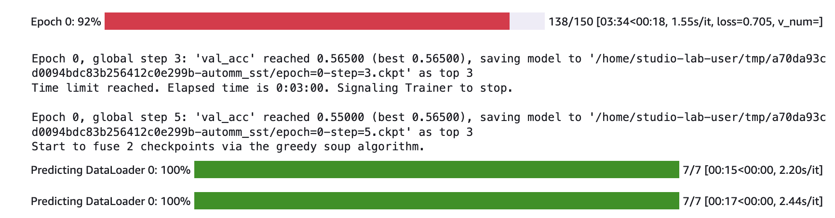

### Evaluate

After training, we can easily evaluate our predictor on separate test data formatted similarly to our training data.

|  |
| --- |
| test_score = predictor.evaluate(test_data, metrics=['acc', 'f1'])  print(test_score) |

The prediction is poor:

|  |
| --- |
| {'acc': 0.5229357798165137, 'f1': 0.6799999999999999} |

Here we will extend the training to 5 minutes. Run this code to retrain the model with a longer duration.

|  |
| --- |
| predictor = MultiModalPredictor(label='label', eval_metric='acc', path=model_path)  predictor.fit(train_data, time_limit=5*60) |

The model still does not finish training so more time could have been added. For the sake of saving time though I will leave it as is.

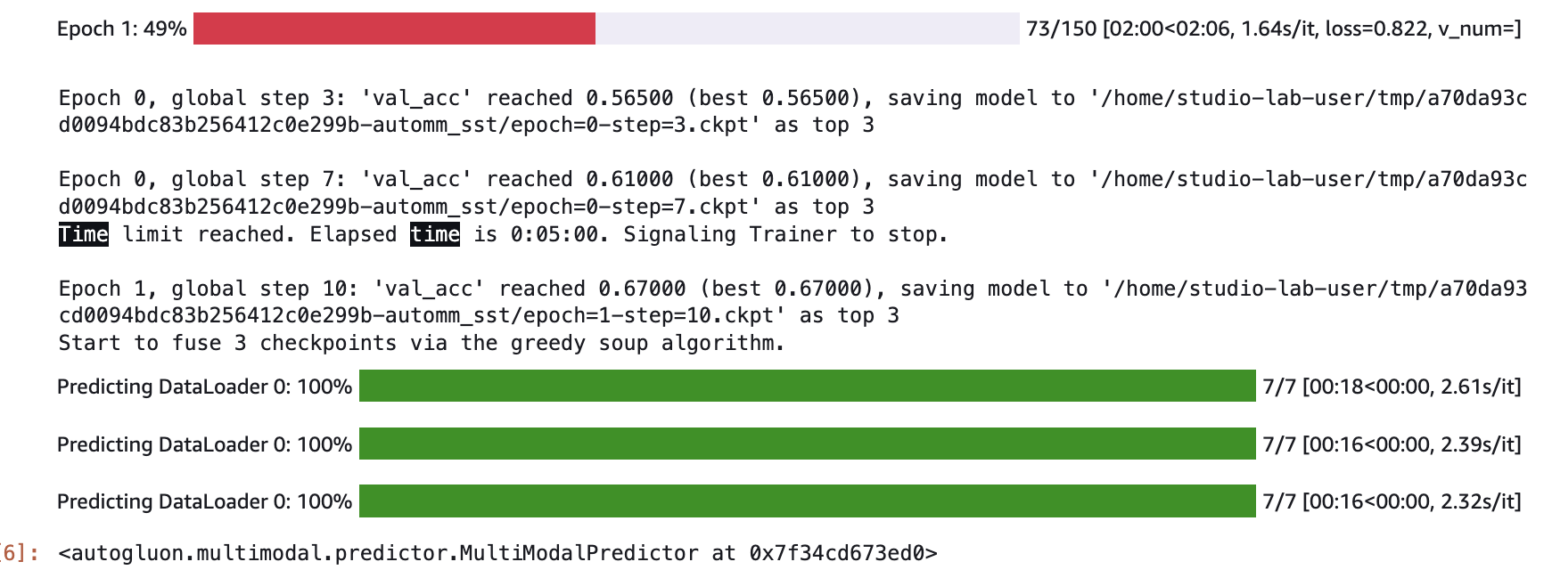

After the model retrains the second time, evaluate it again with this code:

|  |
| --- |
| test_score = predictor.evaluate(test_data, metrics=['acc', 'f1', 'recall', 'precision'])  print(test_score) |

A significant improvement is evident however not all of the epochs were completed so likely more training time could have been allocated.

For the sake of saving time I will leave it as is since the accuracy is decent:

|  |
| --- |
| {'acc': 0.716743119266055, 'f1': 0.6754270696452037, 'recall': 0.5788288288288288, 'precision': 0.8107255520504731} |

### Obtaining and Viewing All Predictions

You could show predictions for the entire data set.

|  |
| --- |
| test_predictions = predictor.predict(test_data)  test_predictions.head() |

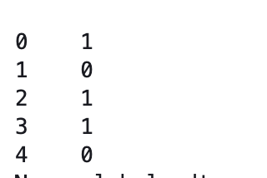

To compare this with actual values run this code:

|  |
| --- |
| print(test_data.head(5)) |

When comparing the actual values with the predictions we can see only one prediction is incorrect but the rest are accurate.



This code tests the model with new data:

|  |
| --- |
| sentence1 = "This was really good. I would watch it again."  sentence2 = "This film was bad. Do not watch it."  predictions = predictor.predict({'sentence': [sentence1, sentence2]})  print('"Sentence":', sentence1, '"Predicted Sentiment":', predictions[0])  print('"Sentence":', sentence2, '"Predicted Sentiment":', predictions[1]) |



Exercise (4 marks)

Test the model with a sentence with your name in it. Make sure you say something nice about yourself. Then show a screenshot here. Show your code here:

|  |
| --- |
| sentence1 = "Victor is very charming."  sentence2 = "Victor has a good sense of humor."  predictions = predictor.predict({'sentence': [sentence1, sentence2]})  print('"Sentence":', sentence1, '"Predicted Sentiment":', predictions[0])  print('"Sentence":', sentence2, '"Predicted Sentiment":', predictions[1]) |

Show your output here:

|  |
| --- |
|  |

It is also possible to show classification probabilities. I notice that the probabilities were not very distinct so it tells me that the model is currently not very good.

|  |
| --- |
| probs = predictor.predict_proba({'sentence': [sentence1, sentence2]})  print('"Sentence":', sentence1, '"Predicted Class-Probabilities":', probs[0])  print('"Sentence":', sentence2, '"Predicted Class-Probabilities":', probs[1]) |



Exercise (1 mark)

Show a screenshot of probabilities that appear for the sentence with your name in it.

|  |
| --- |
|  |

### Save and Load the Model

The trained predictor is automatically saved at the end of .**fit()**, and you can easily reload it.

You can also save the predictor to any location by calling **.save()**.

|  |
| --- |
| new_model_path = "mymodel"  predictor.save(new_model_path)  loaded_predictor = MultiModalPredictor.load(new_model_path)  loaded_predictor.predict_proba({'sentence': [sentence1, sentence2]}) |

When making predictions with predict_proba the probabilities are displayed.

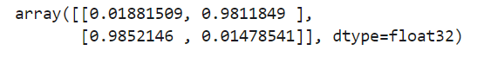

### Continuous Training

It is also possible to resume training in another session. To do this, load the predictor, call .fit() again to continue training the same predictor with new data.

|  |
| --- |
| new_predictor = MultiModalPredictor.load(new_model_path)  new_predictor.fit(train_data, time_limit=30)  test_score = new_predictor.evaluate(test_data, metrics=['acc', 'f1'])  print(test_score) |

## Object Detection

This tutorial is based on the quick start tutorial at <https://auto.gluon.ai/stable/tutorials/object_detection/beginner.html>

There is also some information on working with images that was used in this tutorial. For more information about how to prepare the image data set see:

<https://auto.gluon.ai/stable/tutorials/object_detection/dataset.html>

AutoGluon uses the VOC.xml annotation format which is the same format that was used in class earlier this term in COMP4948 when discussing object detection.

Example : Object Detection

To enable this application in SageMaker Studio Lab, opencv-python-headless is required. “opencv-python” must be uninstalled. To enable this change in library run the following commands:

|  |
| --- |
| !pip uninstall opencv-python -y  !pip install opencv-python-headless |

To download the current dataset of images run this code.

|  |
| --- |
| from autogluon.vision import ObjectDetector  url = 'https://autogluon.s3.amazonaws.com/datasets/tiny_motorbike.zip'  dataset_train = ObjectDetector.Dataset.from_voc(url, splits='trainval') |

The command above extracts the data in your virtual environment. When extracted the folder will look like the following. We will discuss this data format in more detail a bit later.

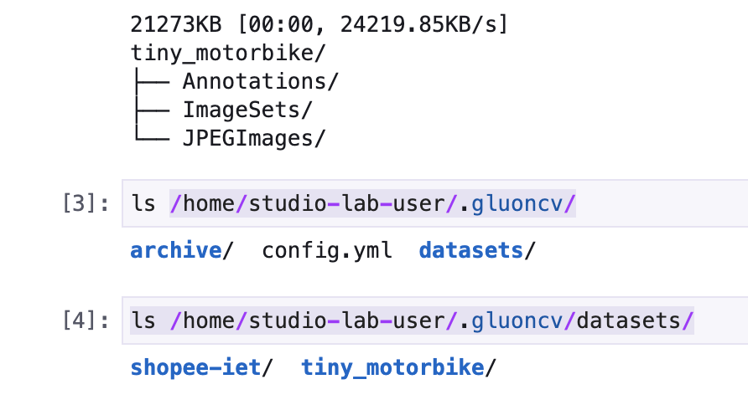

To view the contents of your virtual environment run the following command.

|  |
| --- |
| ls /home/studio-lab-user/.gluoncv/ |

The output will show **archive/ config.xml datasets/**

This command shows the folders that are contained within the datasets directory.

|  |
| --- |
| ls /home/studio-lab-user/.gluoncv/datasets/ |

The output will show **shopee-iet/** **tiny_motorbike/**

You will notice that there are **train.txt** and **test.txt** files in the **/ImageSets/Main** folder. To read the test.txt file you could run this command:

|  |
| --- |
| cat /home/studio-lab-user/.gluoncv/datasets/tiny_motorbike/tiny_motorbike/ImageSets/Main/test.txt |

The output will show a listing of the image files without their extensions:

000038

000055

000058

…

Note that num_trials=2 above is only used to speed up the tutorial. In normal practice, it is common to only use **time_limit** and to drop **num_trials**. Also note that hyperparameter tuning defaults to random search.

|  |
| --- |
| time_limit = 60*30 # at most 0.5 hour  detector = ObjectDetector()  hyperparameters = {'epochs': 5, 'batch_size': 8}  hyperparameter_tune_kwargs={'num_trials': 2}  detector.fit(dataset_train, time_limit=time_limit, hyperparameters=hyperparameters,  hyperparameter_tune_kwargs=hyperparameter_tune_kwargs) |

When you run the code you will see a warning that ObjectDetector is deprecated. You can ignore the warning since the latest AutoGluon documentation tells us to use ObjectDetector.

The best model cselected is a YOLOv3 model.

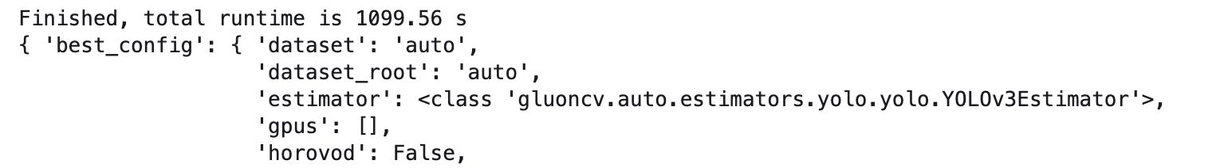

Once the model is fit, it can be evaluated with the test data. The dataset_train and dataset_test are dataframes that contain image paths and labels. Running this command shows the data:

|  |
| --- |
| dataset_test = ObjectDetector.Dataset.from_voc(url, splits='test')  test_map = detector.evaluate(dataset_test)  print("mAP on test dataset: {}".format(test_map[1][-1]))  print(dataset_test.head()) |

The dataframe shows the image path, the object coordinates expessed as percentages of width and height, and image width and height.

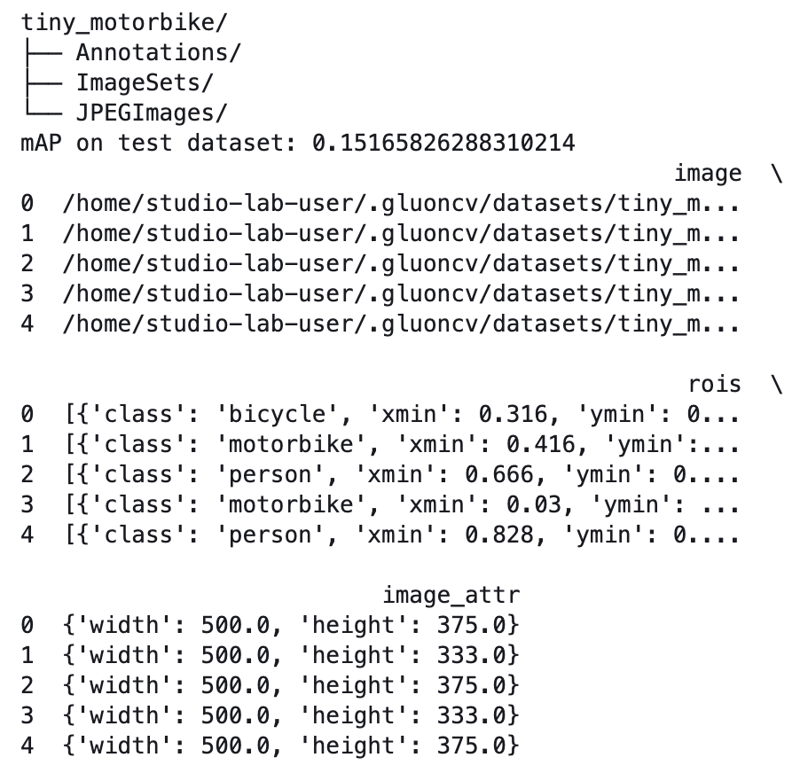

To load and display the first image in the test set, run this code:

|  |
| --- |
| import matplotlib.image as mpimg  import matplotlib.pyplot as plt  image_path = dataset_test.iloc[0]['image']  print(image_path)  img = mpimg.imread(image_path)  imgplot = plt.imshow(img)  plt.grid()  plt.show() |

The output in Figure 1 displays the first image in the test data set.

Figure : Sample Image Output

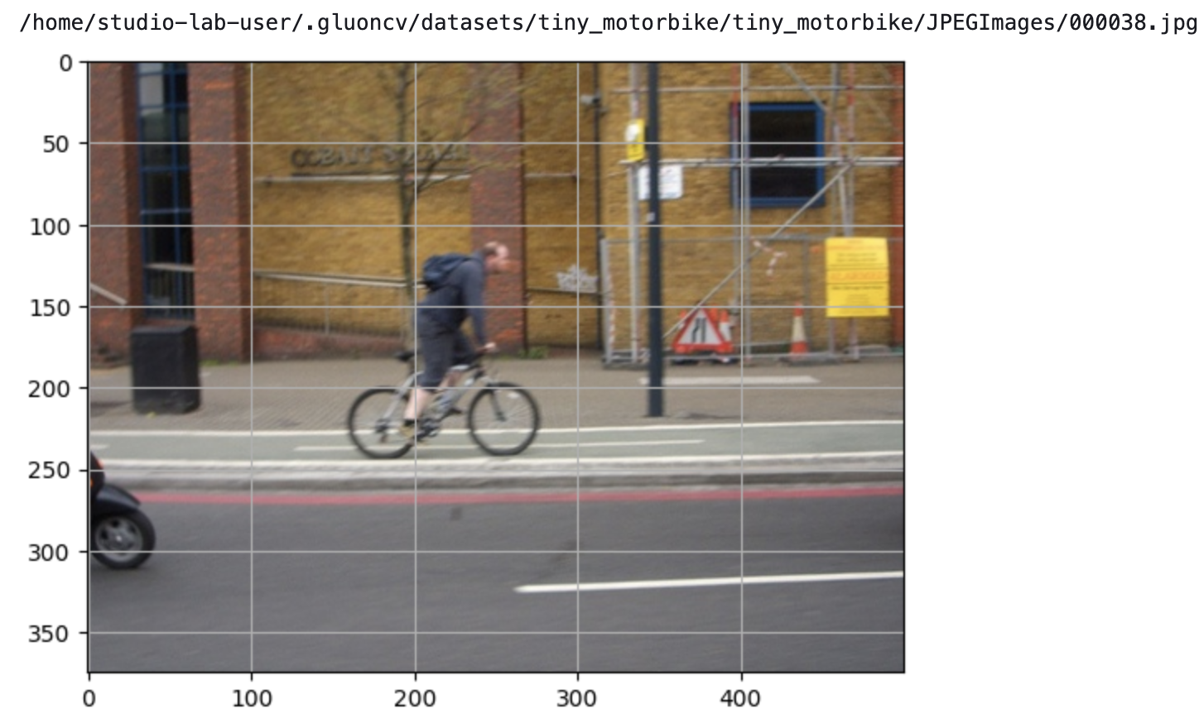

To make a prediction with the first image run this code:

|  |
| --- |
| image_path = dataset_test.iloc[0]['image']  result = detector.predict(image_path)  print(result) |

The output shows the objects detected, their probabilities of correctness, image coordinates expressed as percentages of image height and width.

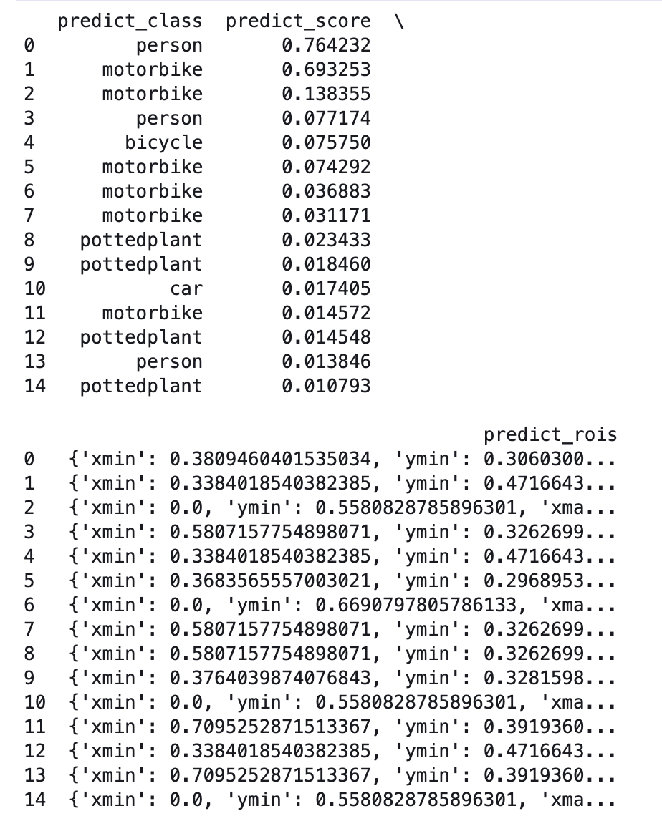

To view the coordinates for the top two objects detected in the prediction for the first test image run this code.

|  |
| --- |
| print(result['predict_rois'][0])  print(result['predict_rois'][1]) |

These coordinates will be used to annotate the image in a couple of steps from now.

{'xmin': 0.3809460401535034, 'ymin': 0.3060300648212433, 'xmax': 0.5189206004142761, 'ymax': 0.5979673862457275}

{'xmin': 0.3384018540382385, 'ymin': 0.4716643691062927, 'xmax': 0.532772421836853, 'ymax': 0.640967607498169}

You can save the model and load it later with this code:

|  |
| --- |
| savefile = 'detector.ag'  detector.save(savefile)  new_detector = ObjectDetector.load(savefile) |

After, notice the file is saved in the project directory.



To display the image dimensions of the first test image that was displayed above in Figure 1 run this code.

|  |
| --- |
| img = mpimg.imread(image_path)  im_w = img.shape[1]  im_h = img.shape[0]  print("width: " + str(im_w))  print("height: " + str(im_h)) |

The output shows width = 500 and height = 375.

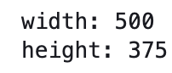

To annotate the image in Figure 1, we need the coordinates that are highlighted by the turquoise title above. The object coordinates that are generated by the predictor are percentages of image width and height. To specify the pixel locations, we must multiple the coordinate percentages by the width and height.

|  |
| --- |
| import pandas as pd  class NaiveDetectionGT:  def __init__(self, image):  self._objects = []  self.image = image  img = mpimg.imread(image)  self.w = img.shape[1]  self.h = img.shape[0]  def add_object(self, name, xmin, ymin, xmax, ymax, difficult=0):  self._objects.append({'image': self.image, 'class': name,  'xmin': xmin / self.w, 'ymin': ymin / self.h,  'xmax': xmax / self.w, 'ymax': ymax / self.h, 'difficult': difficult})  @property  def df(self):  return pd.DataFrame(self._objects)  gt = NaiveDetectionGT(image_path)  gt.add_object('person', 0.4016737937927246*im_w, 0.29098284244537354*im_h,  0.4962182343006134*im_w, 0.612341582775116*im_h)  gt.add_object('motorbike', 0.31154581904411316*im_w, 0.4382806718349457*im_h,  0.5566962361335754*im_w, 0.648590087890625*im_h)  df = gt.df  df |

Now to show the annotated version of the image that was initially displayed in Figure 1, run this code:

|  |
| --- |
| dataset = ObjectDetector.Dataset(df, classes=df['class'].unique().tolist())  dataset.show_images(nsample=1, ncol=1) |

The image in Figure 2 displays the most probable objects that are detected.

Figure : Annotated Image

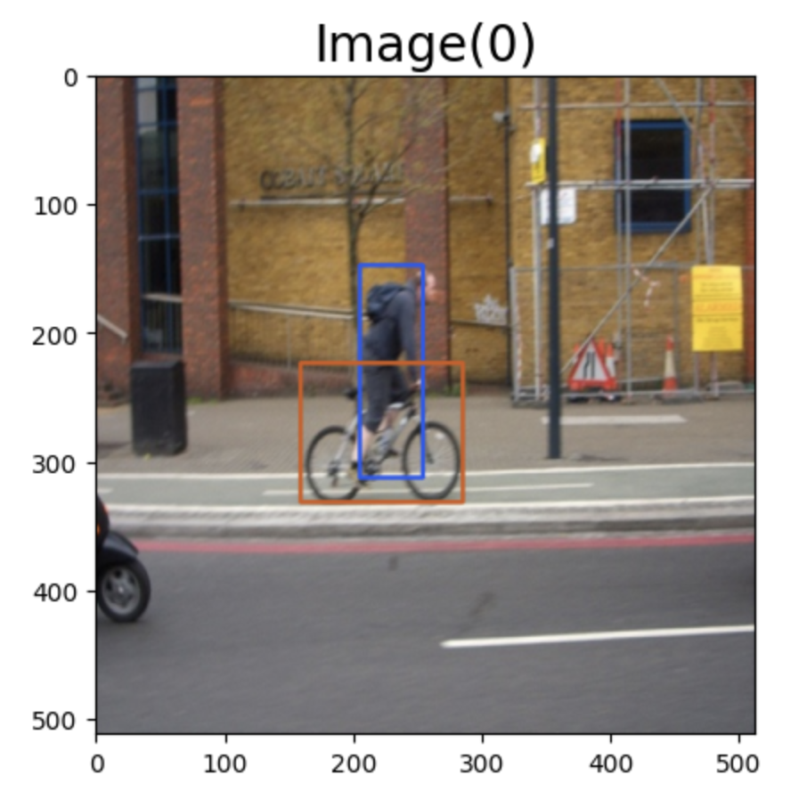

### Uploading your Own Images

Images can be loaded from numerous sources such as S3 buckets and Git repositories. It is also possible to upload your images to the project folder. You will need to ensure the folder structure and files are placed in the same manner as tiny_motorbike.zip which can be downloaded by placing this URL in the browser:

'https://autogluon.s3.amazonaws.com/datasets/tiny_motorbike.zip'

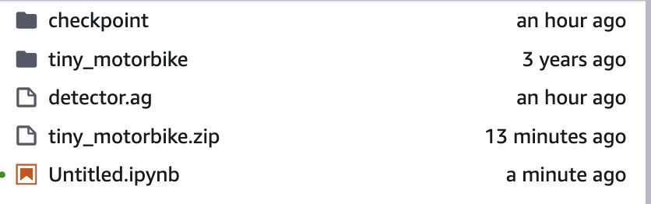

Once the folder has been uploaded, you can then extract the zip folder by running the following command inside Terminal.

**unzip tiny_motorbike.zip**

After extracting, the folder will show the images and annotations.

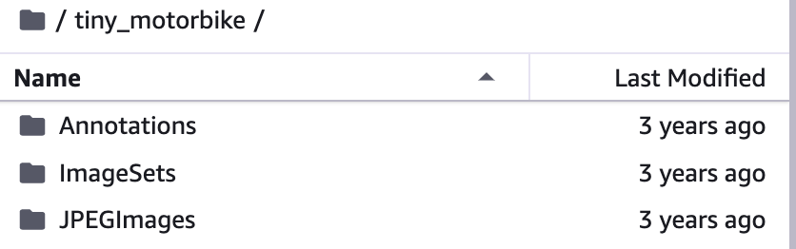

When referencing a folder in the project folder to load images, then syntax like the following can be used:

|  |
| --- |
| from autogluon.vision import ObjectDetector  url = './car_images_autogluon'  dataset_train = ObjectDetector.Dataset.from_voc(url, splits='trainval') |

Exercise (8 marks)

Upload car_images_autogluon.zip. This archive has images that were annotated at makesense.ai using the same process that was discussed when object-detection was covered earlier this term. In the terminal window, unzip the package with the command:

**unzip car_images_autogluon.zip**

The folder will appear after it is extracted.

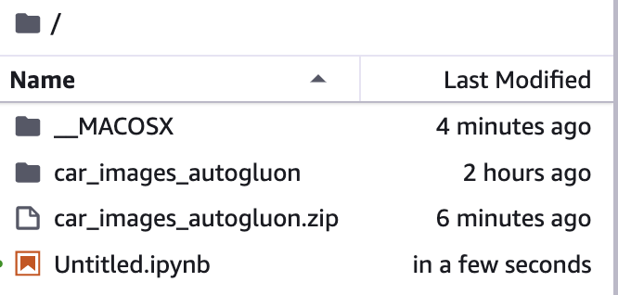

To load the images run this code:

|  |
| --- |
| from autogluon.vision import ObjectDetector  url = './car_images_autogluon'  dataset_train = ObjectDetector.Dataset.from_voc(url, splits='trainval') |

Next, fit the model. After fitting the model, upload a car image with your first name in the name of the file. Then, use the most probable predictions to annotate the detected objects.

Figure : Sample of prediction output



Take a screenshot of your notebook to show the image file in the project folder, the table which contains the file with your first name in it and the annotated image. Your screenshot should look like Figure 3 but the file referenced must have your first name in it or you will not get the mark. Show your screenshot here:

|  |
| --- |
|  |